

**SMART CONTRACT SECURITY AUDIT**

**OF**

**Lisprocoin**

## Audit Introduction

|  |  |
| --- | --- |
| **Auditing Firm** | Lisprocoin |
| **Audit Architecture** | Lisprocoin Auditing Standard |
| **Language** | Solidity |
| **Client Firm** | Lisprocoin LSP20 |
| **Website** | https://www.lisprocoin.net |
| **Twitter** | https://twitter.com/lisprocoin |
| **Report Date** | Dicember 19,2022 |

### About Lisprocoin

Crypto Exchange and swap/ switch Network chain

## Audit Summary

Lisprocoin team has performed a line-by-line manual analysis and automated review of smart contracts. Smart contracts were analyzed mainly for common contract vulnerabilities, exploits, and manipulation hacks. According to the audit:

* Lisprocoin solidity source code has **LOW RISK SEVERITY** v Lisprocoin smart contract has an **ACTIVE OWNERSHIP** v Important owner privileges –**BLACKLIST, WITHDRAW TO TREASURY**
* Lisprocoin smart contract owner has multiple “Write Contract” privileges. Centralization risk correlated to the active owner is **MEDIUM**
* Lisprocoin smart contract utilizes **REBASE.** With rebase, thecirculating token supply adjusts (increases or decreases) automatically or manually according to set parameters.

Be aware that smart contracts deployed on the blockchain aren’t resistant to internal exploit, external vulnerability, or hack. For a detailed understanding of risk severity, source code vulnerability, exploitability, and audit disclaimer, kindly refer to the audit.

### 🚨 Contract address: 0x70E546c7a2cA4495cFcbE263a3b6D5ce68B2204C⛓ Blockchain: Polygon Chain

✅ Verify the authenticity of tisi report on LSP20 GitHub: **https://github.com/15-Lippo/Smart-contract-audit-Lisprocoin**

## Table Of Contents

### Audit Information

Audit Scope .......................................................................................................................................................................................... 5

### Echelon Audit Standard

Audit Methodology ......................................................................................................................................................................... 6

Risk Classification ............................................................................................................................................................................ 8

Centralization Risk ........................................................................................................................................................................... 9

### Smart Contract Risk Assessment

Static Analysis ................................................................................................................................................................................... 10

Software Analysis ........................................................................................................................................................................... 14

Manual Analysis ............................................................................................................................................................................... 18

SWC Attacks ..................................................................................................................................................................................... 20

Risk Status & Radar Chart ........................................................................................................................................................ 22

### Audit Summary

Auditor’s Verdict ............................................................................................................................................................................. 22

### Legal Advisory

Important Disclaimer ................................................................................................................................................................. 24

About InterFi Network ................................................................................................................................................................. 25

# Audit Scope

LSP20 was consulted by Lisprocoin to conduct the smart contract security audit of their solidity source codes. The audit scope of work is strictly limited to the mentioned solidity file(s) only:

v LSP20.sol

**Solidity Source Code On Blockchain (Verified Contract Source Code)**  <https://polygonscan.com/token/0x70E546c7a2cA4495cFcbE263a3b6D5ce68B2204C>

Contract Name: Lisprocoin

Compiler Version: **v0.8.4+commit.c7e474f2**

Optimization Enabled: Yes with 200 runs

Other Settings:

default evmVersion, **GNU GPLv3** [license](https://polygonscan.com/contract-license-types" \o ")

**Solidity Source Code On LSP20 GitHub** https://github.com/15-Lippo/smart-contract-audit-lisprocoin

**SHA-1 Hash**

Solidity source code is audited at hash# d9db2d3028e7615d9bf7fbbb784e765797ffa9ceb4acf6ec8aadeec2427562c9

# Audit Methodology

The scope of this report is to audit the smart contract source code of Lisprocoin. LSP20 has scanned contracts and reviewed codes for common vulnerabilities, exploits, hacks, and backdoors. Due to being out of scope, LSP20 has not tested contracts on testnet to assess any functional flaws. Below is the list of commonly known smart contract vulnerabilities, exploits, and hacks:

### Category

* Re-entrancy v Unhandled Exceptions v Transaction Order Dependency
* Integer Overflow

**Smart Contract Vulnerabilities** v Unrestricted Action v Incorrect Inheritance Order v Typographical Errors v Requirement Violation

* Gas Limit and Loops v Deployment Consistency v Repository Consistency v Data Consistency v Token Supply Manipulation

**Source Code Review** v Access Control and Authorization

* Operations Trail and Event Generation v Assets Manipulation v Ownership Control v Liquidity Access

### LSP20 Echelon Audit Standard

The aim of LSP20” standard is to analyze smart contracts and identify the vulnerabilities and the hacks. Kindly note, LSP20 does not test smart contracts on testnet. It is recommended that smart contracts are thoroughly tested prior to the audit submission. Mentioned are the steps used by LSP20 to audit smart contracts:

1. Solidity smart contract source code reviewal:
   * Review of the specifications, sources, and instructions provided to LSP20 to make sure we understand the size, and scope of the smart contract audit.
   * Manual review of code, which is the process of reading source code line-by-line to identify potential vulnerabilities.
2. Static, Manual, and Software analysis:
   * Test coverage analysis is the process of determining whether the test cases are covering the code and how much code is exercised when we run those test cases.
   * Symbolic execution is analyzing a program to determine what inputs cause each part of a program to execute.
3. Best practices review, which is a review of the smart contracts to improve efficiency, effectiveness, clarify, maintainability, security, and control based on the established industry and academic practices, recommendations, and research.
4. Specific, itemized, actionable recommendations to help you take steps to secure your smart contracts

**Automated 3P frameworks used to assess the smart contract vulnerabilities** v Consensys Tools v SWC Registry v Solidity Coverage v Open Zeppelin Code Analyzer v Solidity Code Complier

# Risk Classification

Smart contracts are generally designed to manipulate and hold funds denominated in ETH/MATIC. This makes them very tempting attack targets, as a successful attack may allow the attacker to directly steal funds from the contract. Below are the typical risk levels of a smart contract:

**Vulnerable**: A contract is vulnerable if it has been flagged by a static analysis tool as such. As we will see later, this means that some contracts may be vulnerable because of a false positive.

**Exploitable:** A contract is exploitable if it is vulnerable and the vulnerability could be exploited by an external attacker. For example, if the “vulnerability” flagged by a tool is in a function that requires owning the contract, it would be vulnerable but not exploitable.

**Exploited:** A contract is exploited if it received a transaction on the main network which triggered one of its vulnerabilities. Therefore, a contract can be vulnerable or even exploitable without having been exploited.

### Risk severity Meaning

This level vulnerabilities could be exploited easily and can lead to asset loss,

|  |  |
| --- | --- |
| **! High** | data loss, asset, or data manipulation. They should be fixed right away. |
| **! Medium** | This level vulnerabilities are hard to exploit but very important to fix, they carry an elevated risk of smart contract manipulation, which can lead to high-risk severity |
| **! Low** | This level vulnerabilities should be fixed, as they carry an inherent risk of future exploits, and hacks which may or may not impact the smart contract execution. |
| **! Informational** | This level vulnerabilities can be ignored. They are code style violations and informational statements in the code. They may not affect the smart contract |

execution

# Centralization Risk

Centralization risk is the most common cause of decentralized finance hacks. When a smart contract has an active contract ownership, the risk related to centralization is elevated. There are some well-intended reasons to be an active contract owner, such as: v Contract owner can be granted the power to pause() or lock() the contract in case of an external attack.

* Contract owner can use functions like, include(), and exclude() to add or remove wallets from fees, swap checks, and transaction limits. This is useful to run a presale, and to list on an exchange.

Authorizing a full centralized power to a single body can be dangerous. Unfortunately, centralization related risks are higher than common smart contract vulnerabilities. Centralization of ownership creates a risk of rug pull scams, where owners cash out tokens in such quantities that they become valueless. **Most important question to ask here is, how to mitigate centralization risk?** Here’s InterFi’s recommendation to lower the risks related to centralization hacks:

* Smart contract owner’s private key must be carefully secured to avoid any potential hack. v Smart contract ownership should be shared by multi-signature (multi-sig) wallets.
* Smart contract ownership can be locked in a contract, user voting, or community DAO can be introduced to unlock the ownership.

**Lisprocoin Centralization Status** v Lisprocoin smart contract has an **active ownership.**

* Smart contract ownership is set to.
* **0x70E546c7a2cA4495cFcbE263a3b6D5ce68B2204C** at the time of the audit.

# Static Analysis

**Symbol**

**Meaning**



🛑

Function can

modify state



💵

Function is payable



🔒

Function is locked



🔐

Function can be accessed



❗

Important functionality

| **\*\*SafeMathInt\*\*** | Library | |||

| └ | mul | Internal 🔒 | | |

| └ | div | Internal 🔒 | | |



| └ | sub | Internal 🔒 | | |

| └ | add | Internal 🔒 | | |

| └ | abs | Internal 🔒 | | | ||||||

|  |  |  |
| --- | --- | --- |
| | **\*\*** | **SafeMath** | **\*\*** | Library | ||| |
| | └ | add | Internal 🔒 | | | | | |

| └ | sub | Internal 🔒 | | |



| └ | sub | Internal 🔒 | | |

| └ | mul | Internal 🔒 | | |

| └ | div | Internal 🔒 | | |

| └ | div | Internal 🔒 | | |

| └ | mod | Internal 🔒 | | |

||||||

| **\*\*ERC20\*\*** | Interface | |||

| └ | totalSupply | External ❗ | |NO❗ |



| └ | balanceOf | External ❗ | |NO❗ |

| └ | allowance | External ❗ | |NO❗ |

| └ | transfer | External ❗ | 🛑 |NO❗ |

| └ | approve | External ❗ | 🛑 |NO❗ |

| └ | transferFrom | External ❗ | 🛑 |NO❗ |

||||||

| **\*\*QuickSwapPair\*\*** | Interface | |||

| └ | name | External ❗ | |NO❗ |

| └ | symbol | External ❗ | |NO❗ |

| └ | decimals | External ❗ | |NO❗ |



| └ | totalSupply | External ❗ | |NO❗ |

| └ | balanceOf | External ❗ | |NO❗ |

| └ | allowance | External ❗ | |NO❗ |

| approve | External ❗ | 🛑 |NO❗ |

| └ | transfer | External ❗ | 🛑 |NO❗ |

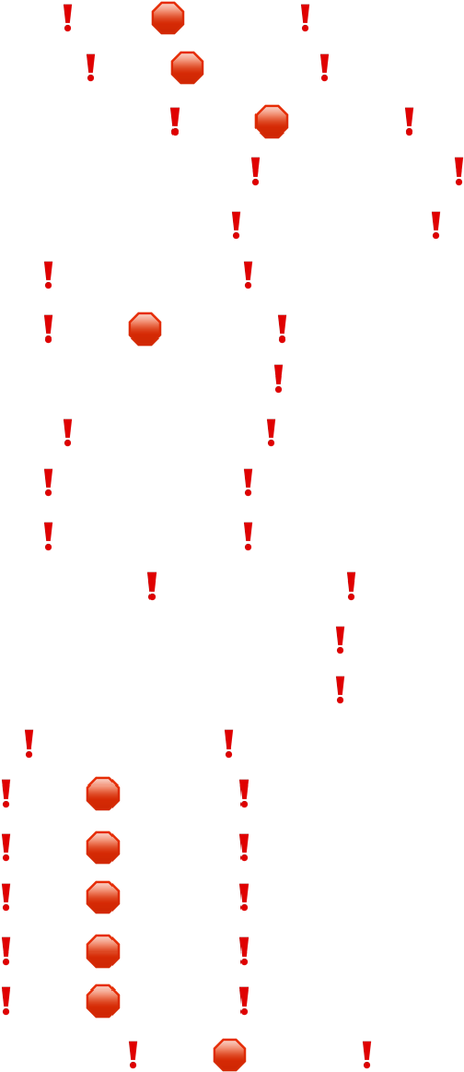| └ | transferFrom | External ❗ | 🛑 |NO❗ |

| └ | DOMAIN_SEPARATOR | External ❗ | |NO❗ |

| └ | PERMIT_TYPEHASH | External ❗ | |NO❗ |

| └ | nonces | External ❗ | |NO❗ |

| └ | permit | External ❗ | 🛑 |NO❗ |

| └ | MINIMUM_LIQUIDITY | External ❗ | |NO❗ |

| └ | factory | External ❗ | |NO❗ |

| └ | token0 | External ❗ | |NO❗ |

| └ | token1 | External ❗ | |NO❗ |

| └ | getReserves | External ❗ | |NO❗ |

| └ | price0CumulativeLast | External ❗ | |NO❗ |



| └ | price1CumulativeLast | External ❗ | |NO❗ |

| └ | kLast | External ❗ | |NO❗ |

| └ | mint | External ❗ | 🛑 |NO❗ |

| └ | burn | External ❗ | 🛑 |NO❗ |

| └ | swap | External ❗ | 🛑 |NO❗ |

| └ | skim | External ❗ | 🛑 |NO❗ |

| └ | sync | External ❗ | 🛑 |NO❗ |

| └ | initialize | External ❗ | 🛑 |NO❗ | ||||||

| **\*\*QuickSwapRouter\*\*** | Interface | |||

| └ | factory | External ❗ | |NO❗ |

| └ | WETH | External ❗ | |NO❗ |

| └ | addLiquidity | External ❗ | 🛑 |NO❗ |

| └ | addLiquidityETH | External ❗ | 💵 |NO❗ |

| └ | removeLiquidity | External ❗ | 🛑 |NO❗ |

| └ | removeLiquidityETH | External ❗ | 🛑 |NO❗ |

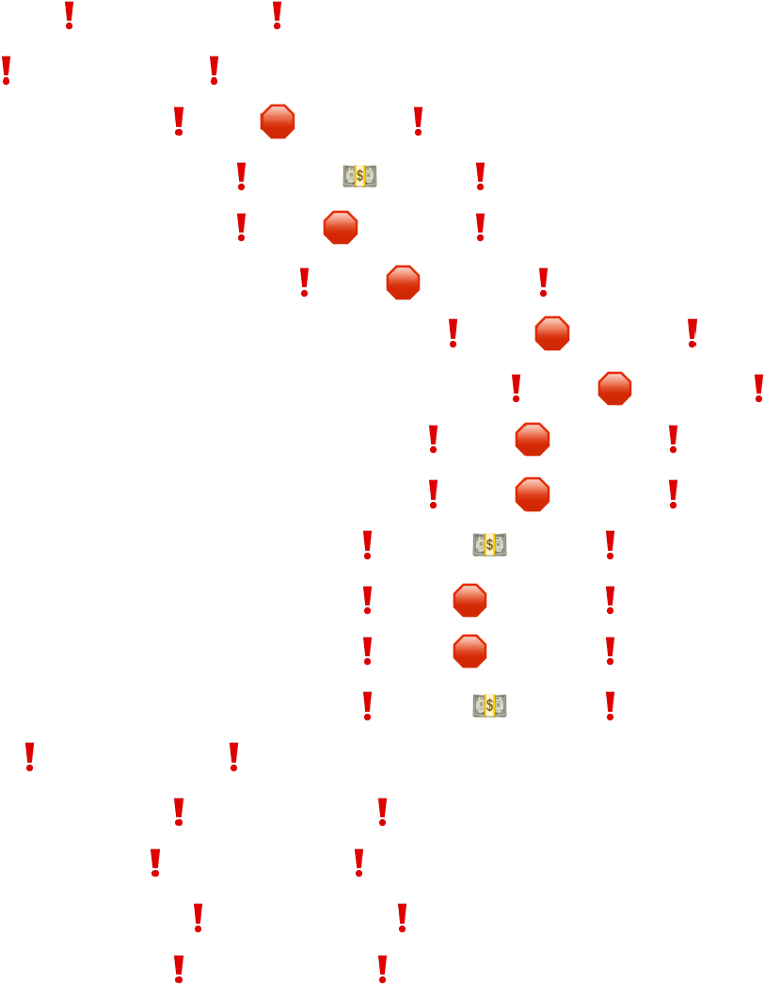| └ | removeLiquidityWithPermit | External ❗ | 🛑 |NO❗ |

| └ | removeLiquidityETHWithPermit | External ❗ | 🛑 |NO❗ |

| └ | swapExactTokensForTokens | External ❗ | 🛑 |NO❗ |

| └ | swapTokensForExactTokens | External ❗ | 🛑 |NO❗ |

| └ | swapExactETHForTokens | External ❗ | 💵 |NO❗ |

| └ | swapTokensForExactETH | External ❗ | 🛑 |NO❗ |

| └ | swapExactTokensForETH | External ❗ | 🛑 |NO❗ |

| └ | swapETHForExactTokens | External ❗ | 💵 |NO❗ |

| └ | quote | External ❗ | |NO❗ |

| └ | getAmountOut | External ❗ | |NO❗ |

| └ | getAmountIn | External ❗ | |NO❗ |

| └ | getAmountsOut | External ❗ | |NO❗ |

| └ | getAmountsIn | External ❗ | |NO❗ |

| └ | removeLiquidityETHSupportingFeeOnTransferTokens | External ❗ | 🛑 |NO❗ |

| └ | removeLiquidityETHWithPermitSupportingFeeOnTransferTokens | External ❗ | 🛑 |NO❗ |

| └ | swapExactTokensForTokensSupportingFeeOnTransferTokens | External ❗ | 🛑 |NO❗ |

| └ | swapExactETHForTokensSupportingFeeOnTransferTokens | External ❗ | 💵 |NO❗ | | └ | swapExactTokensForETHSupportingFeeOnTransferTokens | External ❗ | 🛑 |NO❗ | ||||||



| **\*\*QuickSwapFactory\*\*** | Interface | |||

| └ | feeTo | External ❗ | |NO❗ |

| feeToSetter | External ❗ | |NO❗ |

| └ | getPair | External ❗ | |NO❗ |

| └ | allPairs | External ❗ | |NO❗ |

| └ | allPairsLength | External ❗ | |NO❗ |



| └ | createPair | External ❗ | 🛑 |NO❗ |

| └ | setFeeTo | External ❗ | 🛑 |NO❗ |

| └ | setFeeToSetter | External ❗ | 🛑 |NO❗ |

||||||

|  |  |  |
| --- | --- | --- |
| | **\*\*** | **Ownable** | **\*\*** | Implementation | ||| |
| | └ | <Constructor> | Public ❗ | 🛑 |NO❗ | | | |

| └ | owner | Public ❗ | |NO❗ |

| └ | isOwner | Public ❗ | |NO❗ |

| └ | renounceOwnership | Public ❗ | 🛑 | onlyOwner |



| └ | transferOwnership | Public ❗ | 🛑 | onlyOwner |

| └ | _transferOwnership | Internal 🔒 | 🛑 | |

||||||

| **\*\*ERC20Detailed\*\*** | Implementation | IERC20 |||

| └ | <Constructor> | Public ❗ | 🛑 |NO❗ |

| └ | name | Public ❗ | |NO❗ |

| └ | symbol | Public ❗ | |NO❗ |

| └ | decimals | Public ❗ | |NO❗ |

||||||

|  |  |  |  |  |
| --- | --- | --- | --- | --- |
| | **\*\*** | **ATH** | | **\*\*** | Implementation | ERC20Detailed, Ownable ||| | |
| | └ | <Constructor> | Public ❗ | 🛑 | ERC20Detailed Ownable | | | | | |
| | └ | | | startRebase | | | External ❗ | 🛑 | onlyOwner | |
| | └ | rebase | Internal 🔒 | 🛑 | | | | | | |

| └ | transfer | External ❗ | 🛑 | validRecipient |

| └ | transferFrom | External ❗ | 🛑 | validRecipient |

| └ | _basicTransfer | Internal 🔒 | 🛑 | |

| └ | _transferFrom | Internal 🔒 | 🛑 | |

| └ | takeFee | Internal 🔒 | 🛑 | |

| └ | addLiquidity | Internal 🔒 | 🛑 | swapping |

| └ | swapBack | Internal 🔒 | 🛑 | swapping |

| └ | withdrawAllToTreasury | External ❗ | 🛑 | swapping onlyOwner |



| └ | shouldTakeFee | Internal 🔒 | | |

| └ | shouldRebase | Internal 🔒 | | |

| └ | shouldAddLiquidity | Internal 🔒 | | |

| └ | shouldSwapBack | Internal 🔒 | | |

|  |  |  |  |
| --- | --- | --- | --- |
| | └ | | setAutoRebase | | External ❗ | 🛑 | onlyOwner | | |
| | └ |  | └ | |  | | --- | | setAutoAddLiquidity | | | | External ❗ | 🛑 | onlyOwner | ❗ | |NO❗ | |
| | allowance | External | |

| └ | decreaseAllowance | External ❗ | 🛑 |NO❗ |

| └ | increaseAllowance | External ❗ | 🛑 |NO❗ |



| └ | approve | External ❗ | 🛑 |NO❗ |

| └ | checkFeeExempt | External ❗ | |NO❗ |

| └ | getCirculatingSupply | Public ❗ | |NO❗ |

| └ | isNotInSwap | External ❗ | |NO❗ |

| └ | manualSync | External ❗ | 🛑 |NO❗ |

| └ | setFeeReceivers | External ❗ | 🛑 | onlyOwner |

| └ | getLiquidityBacking | External ❗ | |NO❗ |

| setWhitelist | External ❗ | 🛑 | onlyOwner |



|  |  |  |  |
| --- | --- | --- | --- |
| | └ | | setBotBlacklist | | | External ❗ | 🛑 | onlyOwner | |
| | └ | setPairAddress | External ❗ | 🛑 | onlyOwner | | | | |
| | └ | | setLP | | External ❗ | 🛑 | onlyOwner | | |
| | └ | totalSupply | External ❗ | |NO❗ | | | | |

| └ | balanceOf | External ❗ | |NO❗ |



| └ | isContract | Internal 🔒 | | |

| └ | <Receive Ether> | External ❗ | 💵 |NO❗ |

# Software Analysis

### Function Signatures

16279055 => isContract(address)

39509351 => increaseAllowance(address,uint256)

43509138 => div(int256,int256) bbe93d91 => mul(int256,int256) adefc37b => sub(int256,int256) a5f3c23b => add(int256,int256) 1b5ac4b5 => abs(int256) 771602f7 => add(uint256,uint256) b67d77c5 => sub(uint256,uint256) e31bdc0a => sub(uint256,uint256,string) c8a4ac9c => mul(uint256,uint256) a391c15b => div(uint256,uint256) b745d336 => div(uint256,uint256,string) f43f523a => mod(uint256,uint256) 18160ddd => totalSupply() 70a08231 => balanceOf(address) dd62ed3e => allowance(address,address) a9059cbb => transfer(address,uint256)

095ea7b3 => approve(address,uint256)

23b872dd => transferFrom(address,address,uint256)

06fdde03 => name()

95d89b41 => symbol()

313ce567 => decimals()

3644e515 => DOMAIN_SEPARATOR()

30adf81f => PERMIT_TYPEHASH() 7ecebe00 => nonces(address)

d505accf => permit(address,address,uint256,uint256,uint8,bytes32,bytes32) ba9a7a56 => MINIMUM_LIQUIDITY() c45a0155 => factory() 0dfe1681 => token0() d21220a7 => token1()

0902f1ac => getReserves()

5909c0d5 => price0CumulativeLast()

5a3d5493 => price1CumulativeLast()

7464fc3d => kLast()

6a627842 => mint(address)

89afcb44 => burn(address)

022c0d9f => swap(uint256,uint256,address,bytes) bc25cf77 => skim(address) fff6cae9 => sync()

485cc955 => initialize(address,address) ad5c4648 => WETH() e8e33700 => addLiquidity(address,address,uint256,uint256,uint256,uint256,address,uint256) f305d719 => addLiquidityETH(address,uint256,uint256,uint256,address,uint256) baa2abde => removeLiquidity(address,address,uint256,uint256,uint256,address,uint256) 02751cec => removeLiquidityETH(address,uint256,uint256,uint256,address,uint256)

2195995c =>

removeLiquidityWithPermit(address,address,uint256,uint256,uint256,address,uint256,bool,uint8,bytes3

2,bytes32) ded9382a =>

removeLiquidityETHWithPermit(address,uint256,uint256,uint256,address,uint256,bool,uint8,bytes32,byt es32)

38ed1739 => swapExactTokensForTokens(uint256,uint256,address[],address,uint256)

8803dbee => swapTokensForExactTokens(uint256,uint256,address[],address,uint256)

7ff36ab5 => swapExactETHForTokens(uint256,address[],address,uint256)

4a25d94a => swapTokensForExactETH(uint256,uint256,address[],address,uint256) 18cbafe5 => swapExactTokensForETH(uint256,uint256,address[],address,uint256) fb3bdb41 => swapETHForExactTokens(uint256,address[],address,uint256) ad615dec => quote(uint256,uint256,uint256) 054d50d4 => getAmountOut(uint256,uint256,uint256) 85f8c259 => getAmountIn(uint256,uint256,uint256) d06ca61f => getAmountsOut(uint256,address[]) 1f00ca74 => getAmountsIn(uint256,address[]) af2979eb =>

removeLiquidityETHSupportingFeeOnTransferTokens(address,uint256,uint256,uint256,address,uint256)

5b0d5984 =>

removeLiquidityETHWithPermitSupportingFeeOnTransferTokens(address,uint256,uint256,uint256,address,u int256,bool,uint8,bytes32,bytes32)

5c11d795 =>

swapExactTokensForTokensSupportingFeeOnTransferTokens(uint256,uint256,address[],address,uint256) b6f9de95 => swapExactETHForTokensSupportingFeeOnTransferTokens(uint256,address[],address,uint256)

791ac947 =>

swapExactTokensForETHSupportingFeeOnTransferTokens(uint256,uint256,address[],address,uint256)

017e7e58 => feeTo() 094b7415 => feeToSetter()

e6a43905 => getPair(address,address)

1e3dd18b => allPairs(uint256) 574f2ba3 => allPairsLength() c9c65396 => createPair(address,address) f46901ed => setFeeTo(address) a2e74af6 => setFeeToSetter(address)

8da5cb5b => owner()

8f32d59b => isOwner()

715018a6 => renounceOwnership() f2fde38b => transferOwnership(address) d29d44ee => _transferOwnership(address)

706f86e9 => startRebase() af14052c => rebase()

f0774e71 => _basicTransfer(address,address,uint256) cb712535 => _transferFrom(address,address,uint256) 20cb7bce => takeFee(address,address,uint256) e8078d94 => addLiquidity() 6ac5eeee => swapBack()

bd595581 => withdrawAllToTreasury() 332402f8 => shouldTakeFee(address,address) 63eab10a => shouldRebase() ee0c53c4 => shouldAddLiquidity() 0d5c6cea => shouldSwapBack() e15beb80 => setAutoRebase(bool) cfbac92f => setAutoAddLiquidity(bool) a457c2d7 => decreaseAllowance(address,uint256) d4399790 => checkFeeExempt(address)

2b112e49 => getCirculatingSupply()

83b4ac68 => isNotInSwap()

753d02a1 => manualSync()

3c8e556d => setFeeReceivers(address,address,address,address) d51ed1c8 => getLiquidityBacking(uint256) 854cff2f => setWhitelist(address) 37c9be87 => setBotBlacklist(address,bool) a22d4832 => setPairAddress(address)

2f34d282 => setLP(address)

# Manual Analysis

### Function Description Available Status

|  |  |  |  |
| --- | --- | --- | --- |
| **Total Supply** | provides information about the total token supply | Yes | **Passed** |
| **Balance Of** | provides account balance of the owner's account | Yes | **Passed** |
| **Transfer** | executes transfers of a specified number of tokens to a specified address | Yes | **Passed** |
| **Approve** | allow a spender to withdraw a set number of tokens from a specified account | Yes | **Passed** |
| **Allowance** | returns a set number of tokens from a spender to the owner | Yes | **Passed** |
| **Rebase** | circulating token supply adjusts (increases or decreases) automatically according to a token's price fluctuations | Yes | **Passed** |
| **Blacklist** | stops specified wallets from interacting with the smart contract function modules | Yes | **! Low** |
| **Transfer Ownership** | executes transfer of contract ownership to a specified wallet | Yes | **Passed** |
| **Renounce**  **Ownership** | executes transfer of contract ownership to a dead address | Yes | **Passed** |

**Notable Information** 📝 v Smart contract utilizes **SafeMath** function to avoid common smart contract vulnerabilities.

string private _name **=** "Lisprocoin"; *library* SafeMath **{**

*function* add(uint256 a, uint256 b) internal pure returns (uint256) **{** uint256 c **=** a **+** b;

require(c **>=** a, "SafeMath: addition overflow");

*function* sub(uint256 a, uint256 b) internal pure returns (uint256) **{** return sub(a, b, "SafeMath: subtraction overflow"); uint256 c **=** a **\*** b;

require(c **/** a **==** b, "SafeMath: multiplication overflow"); return c;

*function* div(uint256 a, uint256 b) internal pure returns (uint256) **{** return div(a, b, "SafeMath: division by zero");

*function* mod(uint256 a, uint256 b) internal pure returns (uint256) **{** return mod(a, b, "SafeMath: modulo by zero");

* Smart contract owner can **blacklist** certain wallets from interacting with the contract function modules.

*function* setBotBlacklist(address _botAddress, bool _flag) require( isContract(_botAddress),

"only contract address, not allowed exteranlly owned account"

* Lisprocoin smart contract utilizes **rebase.** With rebase, thecirculating token supply adjusts (increases or decreases) automatically or manually according to set parameters. v Smart contract owner can **withdraw $LSP20 tokens** from the token contract to treasury.

*function* withdrawAllToTreasury() external swapping onlyOwner **{** uint256 amountToSwap = _gonBalances[address(**this**)].div(

* Smart contract has a **low severity issue** which may or may not create any functional vulnerability.

**"severity": 8, (! Low Severity)**

**“Expected token Comma got 'Identifier'”**

# SWC Attacks

#### SWC ID Description Status

|  |  |  |  |  |
| --- | --- | --- | --- | --- |
| **SWC-101** | Integer Overflow and Underflow | **Passed** | | |
| **SWC-102** | Outdated Compiler Version | **! Informational** | | |
| **SWC-103** | Floating Pragma | **Passed** | | |
| **SWC-104** | Unchecked Call Return Value | **Passed** | | |
| **SWC-105** | Unprotected Ether Withdrawal | **Passed** | | |
| **SWC-106** | Unprotected SELF-DESTRUCT Instruction | **Passed** | | |
| **SWC-107** | Re-entrancy | **! Low** | | |
| **SWC-108** | State Variable Default Visibility | **Passed** | | |
| **SWC-109** | Uninitialized Storage Pointer | **Passed** | | |
| **SWC-110** | Assert Violation | **Passed** | | |
| **SWC-111** | Use of Deprecated Solidity Functions | **Passed** | | |
| **SWC-112** | Delegate Call to Untrusted Callee | **Passed** | | |
| **SWC-113** | DoS with Failed Call | **Passed** | | |
| **SWC-114** | Transaction Order Dependence | **Passed** | | |
| **SWC-115** | Authorization through tx.origin | **Passed** | | |
| **SWC-116** | Block values as a proxy for time | **Passed** | | |
| **SWC-117** | Signature Malleability | **Passed** | | |
| **SWC-118** | Incorrect Constructor Name | **Passed** | | |
| **SWC-119** | Shadowing State Variables | | **Passed** |
| **SWC-120** | Weak Sources of Randomness from Chain Attributes | | **Passed** |
| **SWC-121** | Missing Protection against Signature Replay Attacks | | **Passed** |
| **SWC-122** | Lack of Proper Signature Verification | | **Passed** |
| **SWC-123** | Requirement Violation | | **Passed** |
| **SWC-124** | Write to Arbitrary Storage Location | | **Passed** |
| **SWC-125** | Incorrect Inheritance Order | | **Passed** |
| **SWC-126** | Insufficient Gas Griefing | | **Passed** |
| **SWC-127** | Arbitrary Jump with Function Type Variable | | **Passed** |
| **SWC-128** | DoS With Block Gas Limit | | **Passed** |
| **SWC-129** | Typographical Error | | **Passed** |
| **SWC-130** | Right-To-Left-Override control character (U+202E) | | **Passed** |
| **SWC-131** | Presence of unused variables | | **Passed** |
| **SWC-132** | Unexpected Ether balance | | **Passed** |
| **SWC-133** | Hash Collisions With Multiple Variable Length Arguments | | **Passed** |
| **SWC-134** | Message call with the hardcoded gas amount | | **Passed** |
| **SWC-135** | Code With No Effects (Irrelevant/Dead Code) | | **Passed** |
| **SWC-136** | Unencrypted Private Data On-Chain | | **Passed** |

| SMART CONTRACT SECURITY AUDIT OF Lisprocoin.

# Risk Status & Radar Chart

#### Risk Severity Status

|  |  |
| --- | --- |
| **High** | No high severity issues identified |
| **Medium** | No medium severity issues identified |
| **Low** | 2 low severity issues identified |
| **Informational** | 1 informational severity issue identified |
| **Centralization Risk** | Active contract ownership identified |
|  |  |

**Score out of 100**

Compiler Check

75

80

85

90

95

100

Static Analysis

Software Analysis

Manual Analysis

Interface Safety

# Auditor’s Verdict

LSP20 team has performed a line-by-line manual analysis and automated review of smart contracts. Smart contracts were analyzed mainly for common contract vulnerabilities, exploits, and manipulation hacks. According to the audit:

* Lisprocoin smart contract source code has **LOW RISK SEVERITY** v Lisprocoin smart contract has an **ACTIVE OWNERSHIP**
* Lisprocoin centralization risk correlated to the active owner is **MEDIUM**

### Note for stakeholders

* Be aware that active smart contract owner privileges constitute an elevated impact on smart contract safety and security.
* If the smart contract is not deployed on any blockchain at the time of the audit, the contract can be modified or altered before blockchain development. Verify contract’s deployment status in the audit report.
* Make sure that the project team’s KYC/identity is verified by an independent firm.
* Always check if the contract’s liquidity is locked. A longer liquidity lock plays an important role in the project’s longevity. It is recommended to have multiple liquidity providers. v Examine the unlocked token supply in the owner, developer, or team’s private wallets. Understand the project’s tokenomics, and make sure the tokens outside of the LP Pair are vested or locked for a longer period.

# Important Disclaimer

LSP20 provides contract development, testing, auditing and project evaluation services for blockchain projects. The purpose of the audit is to analyze the on-chain smart contract source code and to provide a basic overview of the project. **This report should not be transmitted, disclosed, referred to, or relied upon by any person for any purpose without InterFi’s prior written consent.**

LSP20 provides the easy-to-understand assessment of the project, and the smart contract (otherwise known as the source code). The audit makes no statements or warranties on the security of the code. It also cannot be considered as enough assessment regarding the utility and safety of the code, bug-free status, or any other statements of the contract. While we have used all the data at our disposal to provide the transparent analysis, it is important to note that you should not rely on this report only — we recommend proceeding with several independent audits and a public bug bounty program to ensure the security of smart contracts. **Be aware that smart contracts deployed on a blockchain aren’t resistant to external vulnerability, or a hack. Be aware that active smart contract owner privileges constitute an elevated impact on smart contract safety and security. Therefore, LSP20 not guarantee the explicit security of the audited smart contract.**

The analysis of the security is purely based on the smart contracts alone. No applications or operations were reviewed for security. No product code has been reviewed.

**This report should not be considered as an endorsement or disapproval of any project or team.** The information provided in this report does not constitute investment advice, financial advice, trading advice, or any other sort of advice and you should not treat any of the report’s content as such. Do conduct your due diligence and consult your financial advisor before making any investment decisions.

# About LSP20

LSP20 Network provides intelligent blockchain solutions. InterFi is developing an ecosystem that is seamless and responsive. Some of our services: Blockchain Security, Token Launchpad, NFT Marketplace, etc. **LSP20 mission is to interconnect multiple services like Blockchain Security, DeFi, Gaming, and Marketplace under one ecosystem that is seamless, multi-chain compatible, scalable, secure, fast, responsive, and easy to use.**

LSP20 is built by a decentralized team of UI experts, contributors, engineers, and enthusiasts from all over the world. Our team currently consists of 6+ core team members, and 10+ casual contributors. **LSP20 provides manual, static, and automatic smart contract analysis, to ensure that project is checked against known attacks and potential vulnerabilities.**